Exp.No:22
22. Perform Sharpening of Image using Laplacian mask with positive centre coefficient.

Aim:
To sharpen an image using a Laplacian mask with a positive center coefficient using OpenCV.
Mask:
0 -1 0
-1 5 -1
0 -1 0
Procedure:
- Start the program.
- Import OpenCV and NumPy.
- Read the input image puppy.jpg.
- Check whether the image is loaded.
- Define the Laplacian sharpening mask.
- Apply the mask using cv2.filter2D().
- Display the original and sharpened images.
- Save the output image.
- Stop the program.
Program:
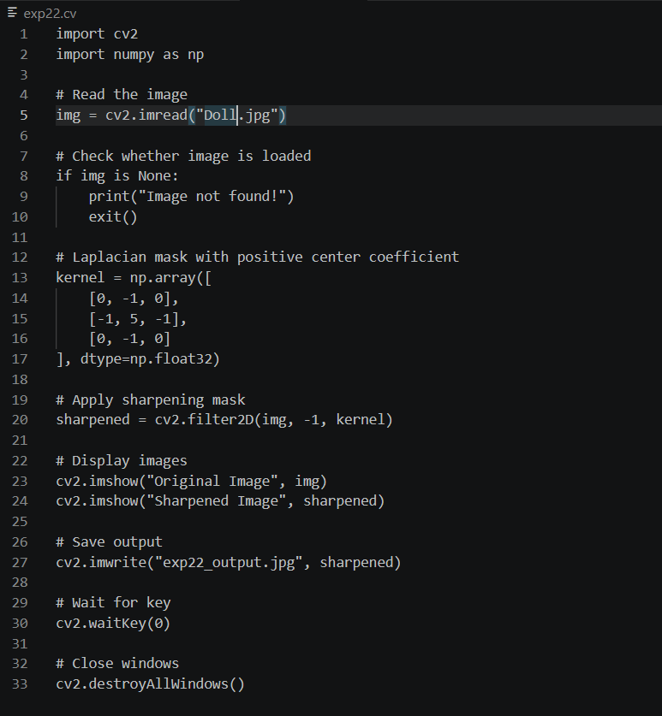

Input:

Output:
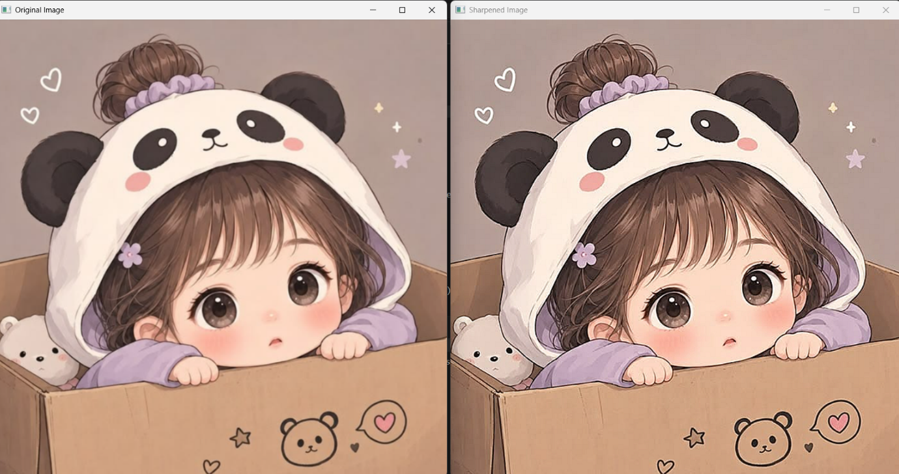
Result:
The image was successfully sharpened using a Laplacian mask with a positive centre coefficient, and the sharpened image was displayed and saved successfully.

